**VELAMMAL BODHI CAMPUS**

**PART TEST-I**

**CLASS:X** **MATHS**  **Date : 07.10.2023**

**Duration : 3Hrs. Marks : 80**

**General Instructions:**

1. This Question Paper has 5 Sections A, B, C, D and E.

2. Section A has 20 MCQs carrying 1 mark each

3. Section B has 5 questions carrying 02 marks each.

4. Section C has 6 questions carrying 03 marks each.

5. Section D has 4 questions carrying 05 marks each.

6. Section E has 3 case based integrated units of assessment (04 marks each) with sub- parts of the values of 1, 1 and 2 marks each respectively.

7. All Questions are compulsory. However, an internal choice in 2 Qs of 5 marks, 2 Qs of 3 marks and 2 Questions of 2 marks has been provided. An internal choice has been provided in the 2marks questions of Section E

8. Draw neat figures wherever required. Take π =22/7 wherever required if not stated.

**Section-A**

|  |
| --- |
| **I. Section A has 20 MCQs carrying 1 mark each.** |
|  |

1. Let a and b be two positive integers such that a=p3q4 and b=p2q3 , where p and q are prime numbers .If HCF(a,b) = pmqn and LCM (a,b)=prqs , then (m+n)(r+s)=

(a)15 (b)30 (c)35 (d)72

2.If n is a natural number , then 2(5n+6n) always ends with:

(a)1 (b)4 (c)3 (d)2

3. If α and β are the zeroes of f(x)=2x2+8x-8, then :

(a)α+β=αβ (b)α+β>αβ (c)α+β<αβ (d) α+β+αβ=0

4.A quadratic polynomial , the sum of whose zeroes is 0 and one zero is 4, is:

(a)x2-16 (b)x2+16 (c)x2+4 (d)x2-4

5.The pair of linear equations 2x=5y+6 and 15y=6x-18 represents two lines which are:

(a)intersecting (b)parallel (c)coincident (d)either intersecting or parallel.

6.If the pair of equations x + y = $\sqrt{2}$ and x sin θ + y cos θ =1 has infinitely many solutions,

then θ is equal to:

(a)300 (b)450 (c)600 (d)900

7.Find the value of k for which the system of equations x+3y =4 and 3x+ky+12=0 are inconsistent.

(a)k=12 (b)k= -12 (c)k=9 (d)k=-9

8.The roots of the equation x2 +3x-10=0 are:

(a)2 ,-5 (b)-2,5 (c)2,5 (d)-2,-5

9.The value of k for which the equation 4x2 +kx+9=0 has equal roots, is:

(a)- (b) (c) (d)

10. The quadratic equation x2 +dx-8=0 has :

(a)no real roots (b)real and distinct roots (c)real and equal root (d)real and imaginary roots

11.5th term of the sequence , whose nth term is 4n+2, is :

(a)20 (b)22 (c)18 (d)23

12.If k+2 , 4k-6 and 3k-2 are three consecutive terms of an AP, then the value of k is :

(a)3 (b)-3 (c)-4 (d)4

13.In an AP , if a=5 , d=3 and n =10,then the value of a10 is:

(a)31 (b)32 (c)34 (d)36

14.If ΔPQR ~ ΔABC; PQ= 6cm and AB=8cm and the perimeter of Δ ABC is 36 cm then the perimeter of ΔPQR is:

(a)20.25cm (b)27cm (c)48cm (d)64cm

15.A vertical stick 12 m long casts a shadow 8 m long on the ground. At the same time, a tower casts the shadow 40m long on the ground . Then ,the height of the tower is:

(a)65m (b)60m (c)70m (d)72m

16. The distance of the point (-6,8) from the X-axis is:

(a)6 units (b)-6units (c)8units (d)10units

17.The distance between the points (a cos θ + b sin θ , 0) and (0, a sin θ- b cos θ) is :

(a)a2+b2 (b)a+b (c)a2-b2 (d)

18.If p (-1,1) is the midpoint of the line segment joining A(-3,b) and B (1, b+4), then b=

(a)1 (b)-1 (c)2 (d)0

19. **Assertion (A):** The nth term of the sequence -8,-4,0,4,…..is 4n-12.

**Reason(R):** The nth term of an AP is determined by an = a+(n-1) d.

(a) Both assertion(A)and reason (R)are true and reason (R)is the correct explanation of assertion (A)

(b) Both assertion (A) and reason (R) are true and reason (R) is not the correct explanation of assertion (A)

(c) Assertion (A) is true but reason (R) is false.

(d) Assertion (A) is false but reason (R) is true.

20. **Assertion (A):** All regular polygons of the same number of sides such as equilateral triangles, squares etc, are similar

**Reason(R):** Two polygons of the same number of sides are said to be similar, if their corresponding angles are equal lengths of corresponding sides are proportional.

(a) Both assertion(A)and reason (R)are true and reason (R)is the correct explanation of assertion (A)

(b) Both assertion (A) and reason (R) are true and reason (R) is not the correct explanation of assertion (A)

(c) Assertion (A) is true but reason (R) is false.

(d) Assertion (A) is false but reason (R) is true.

**Section-B**

**II. Section B has 5 questions carrying 02 marks each.**

21. Solve 2x + 3y = 11 and x – 2y = – 12 and hence find the value of ‘m’ for which y = mx + 3.

(or)

If 37x+43y=123 and 43x+37y =117, then solve the equations for the values of x and y.

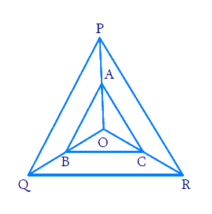22. Find the roots of the quadratic equations x2 + 7x + 5 = 0.

23. In the given figure A, B and C are points on OP, OQ and OR respectively such that AB || PQ and AC || PR. Show that BC || QR.

24. Check whether (5, – 2), (6, 4) and (7, – 2) are the vertices of an isosceles triangle.

25. In a flower bed, there are 23 rose plants in the first row, 21 in the second, 19 in the third, and so on. There are 5 rose plants in the last row. How many rows are there in the flower bed?

(or)

Prove that the sum of the first n terms of an AP is S = $\frac{n}{2}$ [ 2a+ (n-1)d] .

**Section-C**

**III. Section C has 6 questions carrying 03 marks each.**

26. A merchant has 120 litres of oil of one kind, 180 litres of another kind and 240 litres of third kind. He wants to sell the oil by filling the three kinds of oil in tins of equal capacity. What should be the greatest capacity of such a tin?

(or)

Find the greatest number that will divide 445, 572 and 699 leaving remainders 4,5 and 6 respectively.

27. If 𝛼, β are zeroes of quadratic polynomial 5x2 + 5x + 1, find the value of

(i). + (ii) 𝛼-1 + β-1

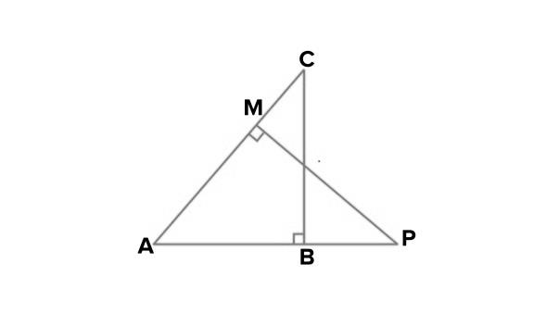

28.In the given figure, ABC and AMP are two right triangles, right angled at B and M respectively. Prove that:

(i) Δ ABC ~ Δ AMP (ii) = .

29. Find the ratio in which the line segment joining A(1, – 5) and B(– 4, 5) is divided by the x-axis. Also find the coordinates of the point of division.

(or)

Find the coordinates of the points which divide the line segment joining A(– 2, 2) and B(2, 8) into

four equal parts.

30. The sum of a two digit number and the number formed by interchanging the digit is 132. If 12 is added to the number , the new number becomes 5 times the sum of the digits. Find the number.

31. If the equation (1+m2) x2 + 2mcx+ (c2- a2) =0 has equal roots, prove that c2 = a2 (1+m2).

**Section-D**

**IV. Section D has 4 questions carrying 05 marks each.**

32. State and prove Basic Proportionality theorem. prove that a line drawn through the mid-point of one side of a triangle parallel to another side bisects the third side.

(or)

Sides AB and AC and median AD of a triangle ABC are respectively proportional to sides PQ and PR and median PM of another triangle PQR. Show that Δ ABC ~ Δ PQR.

33. (i)Prove that 2+5 $\sqrt{3}$ is an irrational number.

(ii)Prove that 4n can never end with digit 0,where n is natural number.

34. A train travels a distance of 480 km at a uniform speed. If the speed had been 8 km/h less, then it would have taken 3 hours more to cover the same distance. Find the speed of the train.

(or)

In a flight of 600 km, a aircraft was slowed down due to bad weather. Its average speed for the trip was reduced by 200 km/hr and the time of flight increased by 30 minutes. Find the duration of flight.

35. Draw the graphs of the equations x – y + 1 = 0 and 3x + 2y – 12 = 0. Determine the coordinates of the vertices of the triangle formed by these lines and the x-axis, and shade the triangular region.

**Section-E**

**V.CASE BASED QUESTION.**

36. In a board game, the no. of sea shells in various cells forms an arithmetic progression.

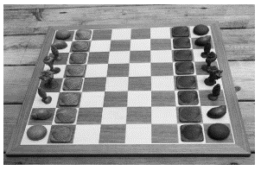If the number of sea shells in the 3rd and 11th cell together is 68 and number of shells in the 11th cell is 24 more than that of 3rd cell

Based on the above information, answer the following questions.

(i)What is the difference between the number of sea shells in the 20th and 18th cells?

(ii) How many sea shells are there in the first cell?

(iii) How many total sea shells are there in first 15 cells?

OR

(iii) What is the sum of number of sea shells in the 8th and 9th cell?

37. Tharunya was thrilled to know that the football tournament is fixed with a monthly timeframe from 20th July to 20th August 2023 and for the first time in the FIFA Women’s World Cup’s history, two nations host in 10 venues. Her father felt that the game can be better understood if the position of players is represented as points on a coordinate plane.

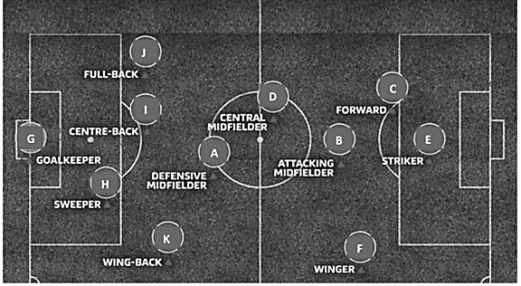

(i)At an instance, the midfielders and forward formed a parallelogram. Find the position of the central midfielder (D) if the position of other players who formed the parallelogram are :- A(1,2), B(4,3) and C(6,6)

(ii) Check if the Goal keeper G(-3,5), Sweeper H(3,1) and Wing-back K(0,3) fall on a same straight line.

[or]

Check if the Full-back J(5,-3) and centre-back I(-4,6) are equidistant from forward C(0,1) and

if C is the mid-point of IJ.

(iii) If Defensive midfielder A(1,4), Attacking midfielder B(2,-3) and Striker E(a,b) lie on the same straight line and B is equidistant from A and E, find the position of E.

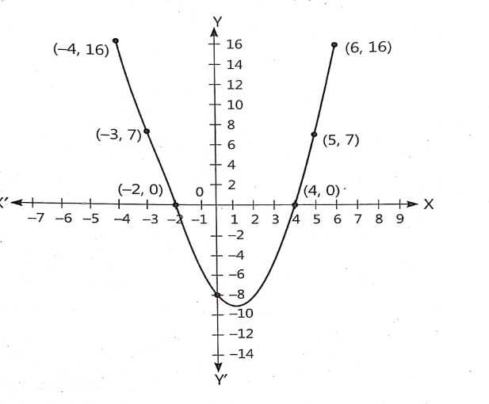38. A student was given a task to prepare a graph of quadratic equation p(x)= -8-2x+x2 . To draw this graph ,he take seven values of y corresponding to different values of x. After plotting the points on the graph paper with suitable values , he obtained the graph as shown below.

(i)What is the shape of graph of a quadratic polynomial?

(ii)Find the zeroes of given quadratic polynomial.

(iii)From the graph, find the value of y corresponding to x = -1.

(or)

The graph of the given quadratic polynomial cut at which points on the X- axis and Y-axis?